

How to Set Up Alarm Notification on EZView?
How to Set Up Alarm Notification on EZView?
Description
Note: This method is applicable to most of the scenarios encountered problems, if the method still cannot solve your problem, it is recommended to consult our Tech Support Team.
https://global.uniview.com/Support/Service_Hotline/
Operating Steps
Step 1 Turn on the Allow Notifications under Me>General>Push Notification Settings on your EZView app.
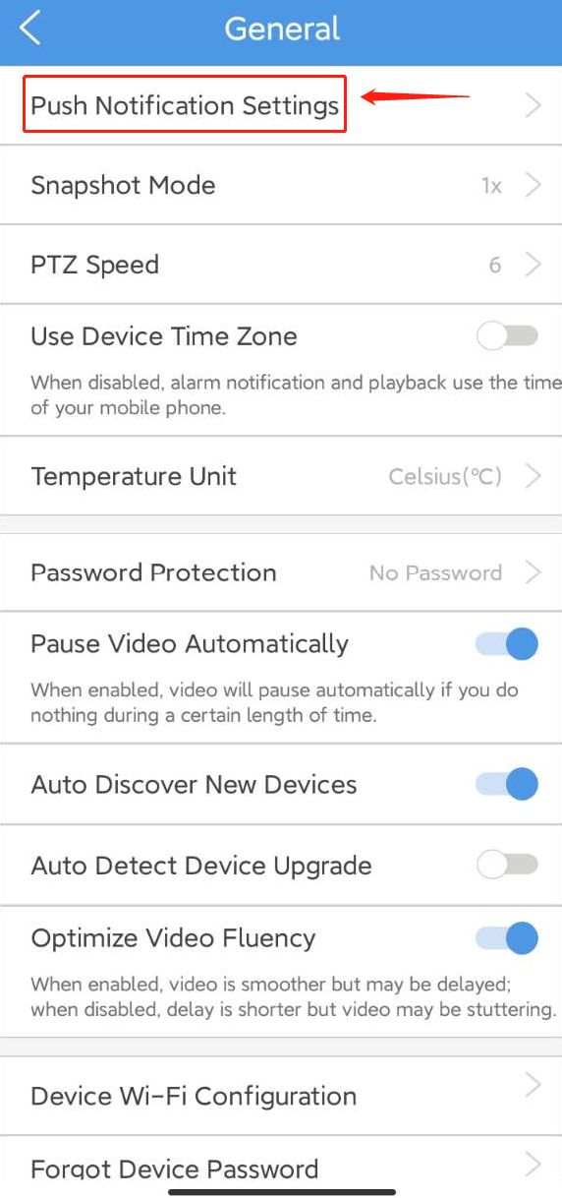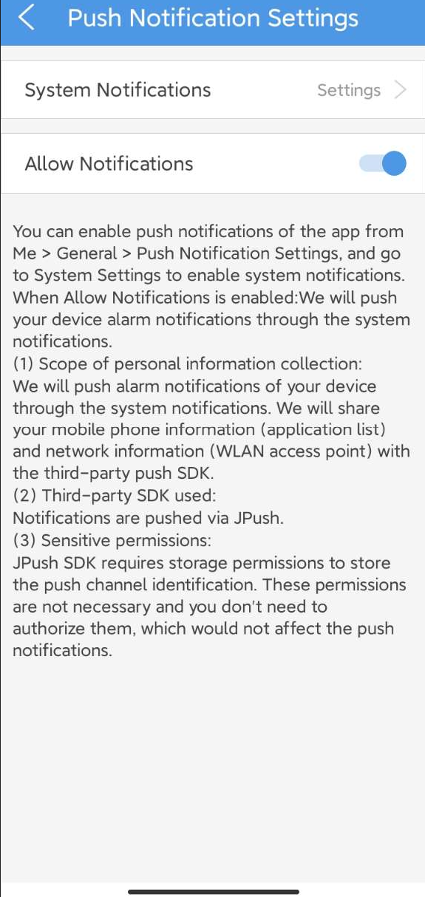
Step 2 Click System Notifications Settings to allow all related permissions for EZView on your phone. Here are the settings of Samsung Android Phone and iPhone.
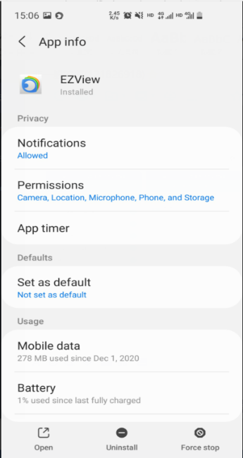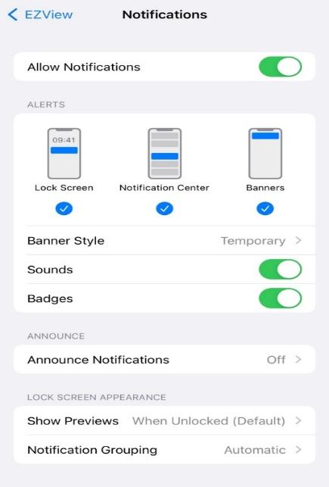
Step 3 Go to Alarm Notifications on the App and then Allow Notifications.
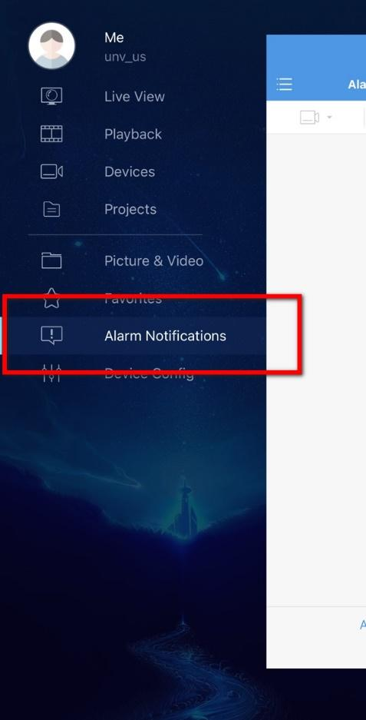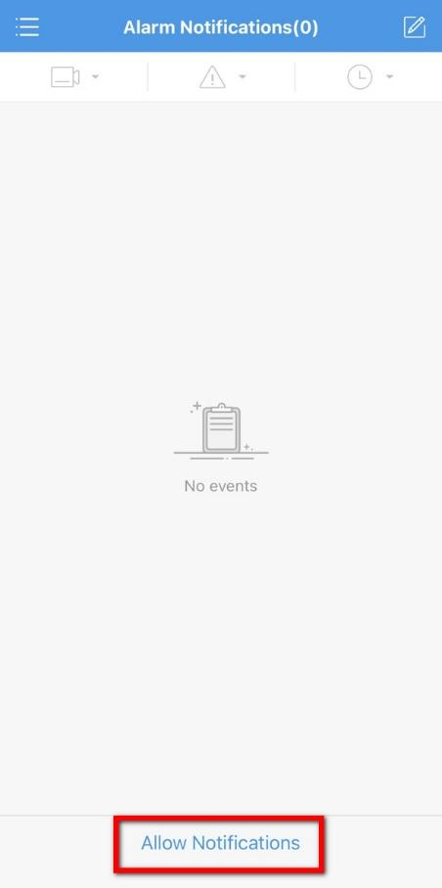
Step 4 Enable the Notification for devices you want to set up and then click Advanced Settings. Turn on the alarm types you want to use and save it. Go back to Alarm Notifications and pull down to refresh. You will get the alarm records then.
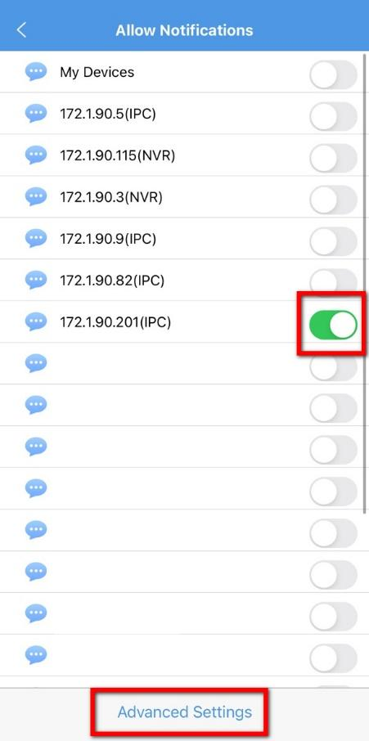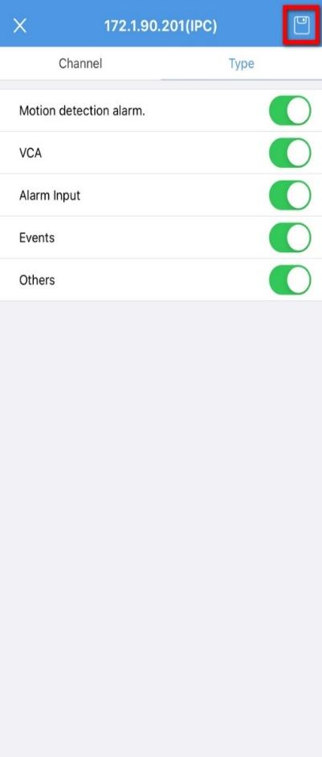
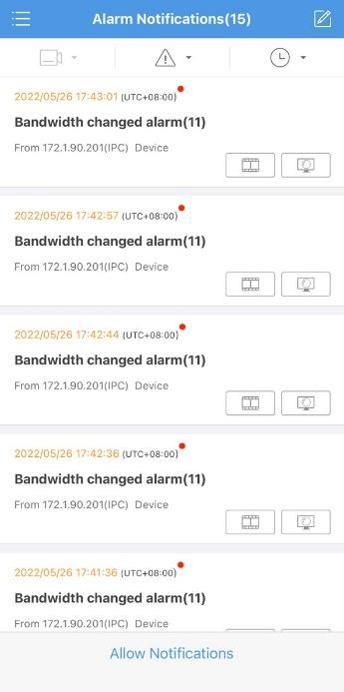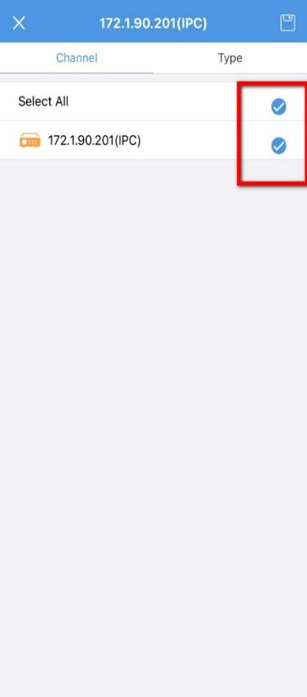
Note: Please set up the alarm rules on the NVR/IPC first.
Step 5 Go to Device Config, click on the device you need to turn the alarm notification on, and then turn on Allow Alarm Notifications.
